- Introduction
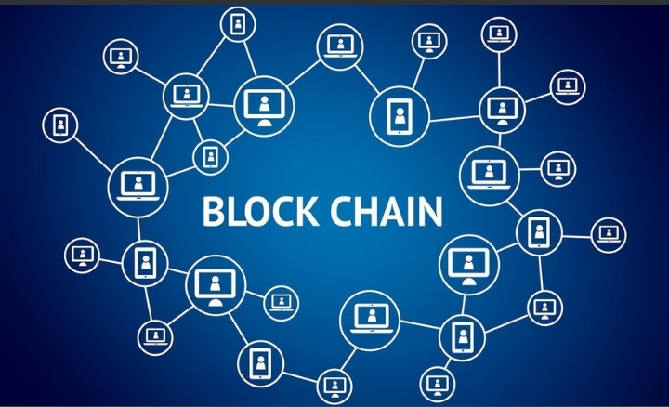
Fig 1

  - What is Blockchain?
It is a type of database.
Blockchain is basically a technique to store information.
Purpose of blockchain is to distribute or record Digital information but no permission for editing.
This technology was introduced in 1991 by Stuart Haber and W.Scott Stornetta.
But it got its first real world application in 2009 with the launch of Bitcoin.
1.2 Why it is called Blockchain?
It collects information in groups and these groups are called blocks.
Each block has limited storage capacity and when one block gets filled it connects with previous filled block. By
This it forms chain (a data chain). That’s why it is called blockchain.

1.3. Elements of Blockchain and How it works?
Block chain is a chain and which each block contains an information.
Each block has cryptographic hash of its previous block. This have generate in every transaction monitor the string of numbers and letters.
1.3.1 How Hashing Works?
Hash is a type of connection in which it converts the import of letter and numbers into a fixed length of encrypted output.
This hash not only depend on transaction but also depends on previous transactions hash in a chain.
If there is a small change in transaction than there is a new hash will be created. Therefore if there is any cheat with the blockchain data the whole setting will change in this way the fraud in this record will identify. That’s why it is a secure option.
Blockchain is a spread in wide networks of computers and each computer has its own Blockchain copy. These computers are known as Nodes. They check the hash to verify is there any changes or not. If any transaction is approved by most of the nodes so, these transactions were written in blocks. These nodes form infrastructure of blockchain they store, spread and preserves the blockchain data.
It is a full node computer type device in which it has full copy of blockchain transaction history.
Block chain update itself in every 10 minutes.

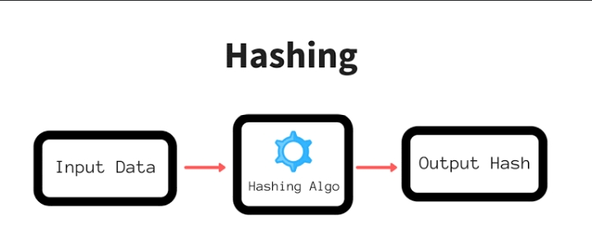
Fig.2

- How Blockchain is useful for bitcoin?

For Bitcoin it is a specific type of database which store every Bitcoin transaction. like Bitcoin types of cryptocurrencies blockchain spreads their options in networks of computers. By this it is very easy to operate these currencies without any central authorities. Using of block chain reduces risk and many processing or transaction phase are eliminate. Blocks in Bitcoin blockchain store data of monetary transaction and it reliable for storing another different types of data also. There are many areas where blockchain infer as useful and make services better of many different important sectors.

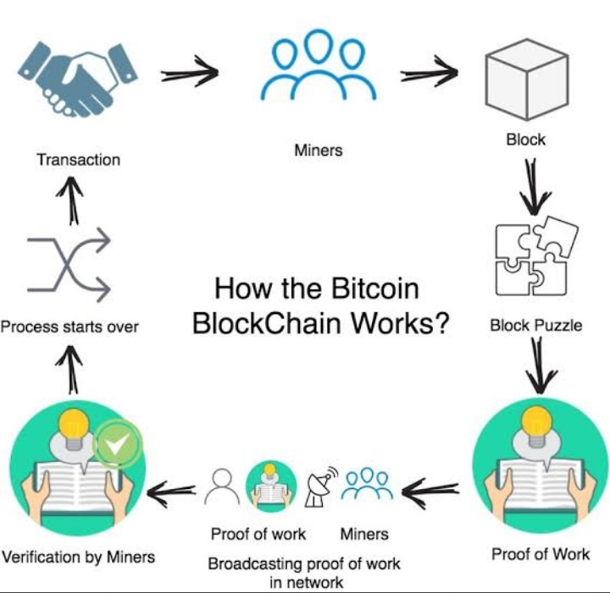
Fig.3

- Difference between Banking and Blockchain

Just like we saw difference between banking and blockchain so in financial institutions mostly Work done only five days in a week. It means if we want to deposit our check in another two days we have to wait and if we deposit it in working days so it Takes time for transaction. That’s why in bank integration transaction process is done by blockchain in 10 minutes. By block chain we can quant exchange fastly between banks and institutions

4.Blockchain in Health centres

In health centers we can use blockchain for storing patients report securely. For this when medical record is generated or sign it can be written in blockchain. By this patient gets proof that their report can’t be changed. While storing these records and blockchain we can use private key for privacy.

Privacy key fig.4

Apart From banks and health centers blockchain can used in voting system and supply chain.

5.Blockchain in Supply chain and Voting system

In supply chain suppliers can record their buying products. By this they can verify the product authenticity.
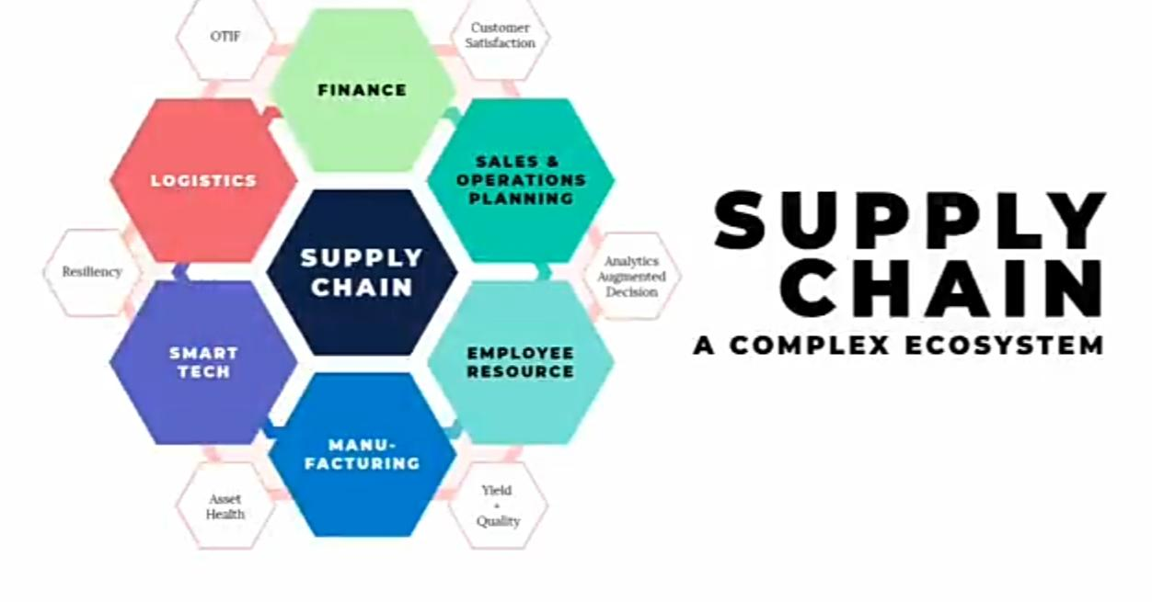
Fig.5
In modern voting system we can stop election fraud by using blockchain or by blockchain protocol in this process transparency can be shown.

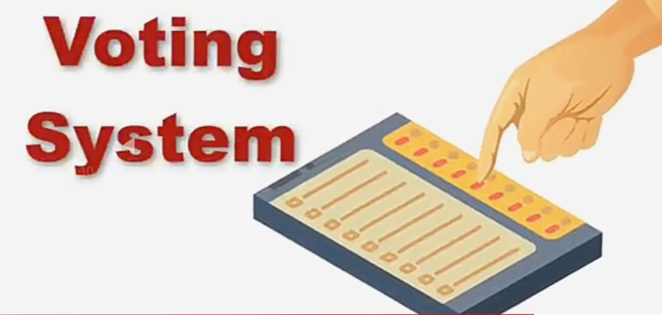
Fig.6

Therefore blockchain can be used in different sectors and by this sometimes we got profit and sometimes loss.
Profit like in transparent technology we can improve accuracy by removing third party verification there is cost reduction and we can store our transaction private.
Loss is that this technology is not free and by its speed and every minute only limited transaction can be done or block chain is used in various illegal works also.

6.Summary

Blockchain is a system of recording information in a way that makes it difficult or impossible to change, hack, or cheat the system.

A blockchain is essentially a digital ledger of transactions that is dupicated and disttributed across the entire network of computer systems on the blockchain. Each block in the chain contains a number of transactions, and every time a new transaction occurs on the blockchain, a record of that transaction is added to every participant’s ledger. The decentralised database managed by multiple participants is known as Distributed Ledger Technology (DLT).

Blockchain is a type of DLT in which transactions are recorded with an immutable cryptographic signature called a hash.
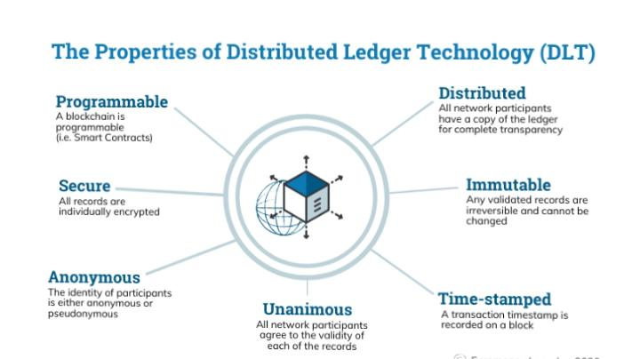
Fig.7

7. Future Work

- Economy and finance will lead blockchain application.
- National cryptocurrencies will appear.
- Block chain integration into government agencies.
- Blockchain meets the Internet of Things.
- Law integration in smart contracts.

References
- AIThority.com
- euromoney.com
- Quick Support

